Software Requirements Specification
Online Exam Portal
Version 1.0
Prepared by:
Rehan S Bawakhan CS820
Yeshaswinie D CS619
Yashwantha R CS614
Yashaswini Singh CS612
Date: 05-09-2026
Status: Draft

Revision History
Version | Date | Author | Change summary | Approval
1.0 | 05-09-2026 | Rehan S Bawakhan CS820  Yeshaswinie D CS619  Yashwantha R CS614  Yashaswini Singh CS612 | First draft, built around the course SRS template and reworked in our own words. | Pending

Approvals
Role | Name
Course Coordinator | Prof. Pavithra

Table of Contents

1. | Introduction
2. | Overall Description
3. | External Interface Requirements
4. | System Features
5. | Non-Functional Requirements
6. | Quality Attributes & Acceptance Tests
7. | System Models and Diagrams
8. | Requirements Traceability Matrix (RTM)

1. Introduction

1.1 Purpose
This document lays out the requirements for the Online Exam Portal — a web application for setting up, running and grading exams online. It's written for the Software Engineering mini-project and is meant to give the development team, the project guide, and whoever evaluates the project a single, unambiguous reference for what the system is supposed to do, how its pieces should talk to each other, and how we'll know a requirement has actually been met.

1.2 Scope
The portal is built around three kinds of users — Admin, Faculty and Student — and covers everything from building a question bank, scheduling and delivering an exam, evaluating it (automatically where possible, manually where it isn't), and generating results, right through to basic admin and monitoring tools. A few things are deliberately out of scope for this version: there's no native mobile app, no payment gateway, and no camera-based/biometric proctoring. If the project continues past this course, these are the natural next additions.

1.3 Audience
Mainly written for the people building and testing this: the dev team and QA, but also the project guide, course coordinator and anyone evaluating the submission.

1.4 Definitions, Acronyms & Abbreviations
Term | Meaning
SRS | Software Requirements Specification
Admin | The system administrator — manages the portal as a whole
Faculty / Examiner | Creates exams and question banks, grades subjective answers
MCQ | Multiple Choice Question
UI / API | User Interface / Application Programming Interface
FR / NFR | Functional Requirement / Non-Functional Requirement
RTM | Requirements Traceability Matrix
OTP | One-Time Password
TLS | Transport Layer Security
WCAG | Web Content Accessibility Guidelines

2. Overall Description

2.1 Product Perspective
This is a standalone system, not an add-on to something that already exists, and it's structured as a fairly conventional three-tier setup:
- Presentation tier — the browser-based UI that Admin, Faculty and Students all use.
- Application tier — handles the actual logic: authentication, scheduling, evaluation, reporting — exposed through REST APIs.
- Data tier — a relational database holding users, exams, questions, responses and results.

2.2 Major Product Functions
- Registration, login and role-based access control.
- Building and organizing a question bank (by subject, difficulty, tags).
- Creating and scheduling exams — duration, marks, negative marking, randomization.
- Delivering the exam securely, with a countdown timer and auto-submit on timeout.
- Auto-grading objective questions, plus a manual workflow for subjective ones.
- Computing results, generating rank lists, and basic performance analytics.
- Admin-side user/course management and system-wide activity logging.

2.3 User Roles & Characteristics
User Class | Characteristics
Administrator | Handles user accounts, courses and system configuration; has access to every module and report.
Faculty / Examiner | Builds question banks and exams, schedules tests, grades subjective answers, and looks at class-level reports.
Student | Registers, logs in, takes scheduled exams within the time given, and checks their own results and feedback afterward.

2.4 Operating Environment
- Client side: any recent browser (Chrome, Firefox, Edge) on Windows, Linux, macOS, Android or iOS.
- Server side: a web/app server — Node.js, Django or Spring Boot, for instance — on Windows Server or Linux.
- Database: MySQL or PostgreSQL.
- Network: needs an internet connection on both the hosting side and the client side.

2.5 Constraints
- Has to run in a standard browser — no plugins or extensions to install.
- Needs to work reasonably well even on a slow or unstable connection.
- Student data and exam records need to follow the institution's data-privacy and academic-integrity rules.
- Has to be buildable within the timeframe and tech stack agreed for this course project.

3. External Interface Requirements

3.1 User Interfaces
- A login/registration screen shared by all three roles.
- A role-specific dashboard (Admin, Faculty, Student) showing relevant stats and shortcuts.
- A question-bank screen for Faculty/Admin — add, edit, delete, bulk import.
- An exam-creation wizard covering duration, marks and scheduling.
- The exam-taking screen itself: question navigator, timer, submit button.
- A results/analytics dashboard with charts and tables for scores and trends.

3.2 Hardware Interfaces
Nothing exotic is needed — a desktop, laptop or smartphone with a screen, a keyboard or touchscreen, and network access covers it. A webcam is optional and would only matter if proctoring gets added later.

3.3 Software Interfaces
- A database (MySQL/PostgreSQL) for persistent storage.
- An email/SMS gateway (e.g. an SMTP service) for notifications.
- Any OS that runs the chosen server/runtime (Windows or Linux) on the backend; any modern browser on the client.

3.4 Communications
- All client-server traffic goes over HTTPS.
- The front end and back end talk to each other through REST APIs.
- The exam timer stays in sync with the server via WebSocket or polling.
Following the reference template, this document works out to 31 functional requirements across Section 4 (at least 15 required), 6 non-functional requirements in Section 5 (at least 5 required), 3 security objectives (at least 2 required), and 6 security requirements in Section 5.1 (at least 5 required).

4. System Features
Every requirement below has an acceptance criterion and a linked test case. IDs follow the pattern OEP-F-###, grouped by module.

4.1 Authentication & Access Control
Lets Admin, Faculty and Students register/log in securely, and keeps each role limited to what it's allowed to do.
Req ID | Requirement | Type | Priority | Source | Acceptance / Test ref | Notes
OEP-F-001 | A new student can sign up using their institutional email or roll number, choosing a password that meets the portal's password policy. | Functional | High | Student / Registrar | AC-OEP-F-001 · TC-Auth-01 | Email/roll no. must be unique
OEP-F-002 | Users log in through a form that checks their email/username and password against the stored, hashed credentials. | Functional | High | All users | AC-OEP-F-002 · TC-Auth-02 | Depends on password hashing service
OEP-F-003 | Role-based access is enforced for Admin, Faculty and Student accounts — each role only sees the screens and API endpoints it is allowed to use. | Functional | High | Security | AC-OEP-F-003 · TC-Auth-03 | Must be checked server-side, not just hidden in the UI
OEP-F-004 | After five failed login attempts in a row, the account is temporarily locked and the event gets written to the audit log. | Functional | Medium | Security | AC-OEP-F-004 · TC-Auth-04 | Requires the audit-log module

4.2 Question Bank Management
Gives Faculty/Admin a way to build and maintain a reusable set of questions, organized by subject and difficulty.
Req ID | Requirement | Type | Priority | Source | Acceptance / Test ref | Notes
OEP-F-010 | Faculty can add MCQ, True/False and Short-Answer questions to a question bank. | Functional | High | Faculty | AC-OEP-F-010 · TC-QB-01 | Question types can be extended later
OEP-F-011 | Questions can be tagged by subject, topic and difficulty so they're easy to filter later. | Functional | Medium | Faculty | AC-OEP-F-011 · TC-QB-02 | -
OEP-F-012 | A whole batch of questions can be imported at once from a CSV/Excel file using the provided template. | Functional | Medium | Faculty | AC-OEP-F-012 · TC-QB-03 | Needs a file-parsing utility
OEP-F-013 | Existing questions can be edited or removed, as long as they aren't already attached to a live or published exam. | Functional | Medium | Faculty | AC-OEP-F-013 · TC-QB-04 | Depends on the exam-lock check

4.3 Exam Creation & Scheduling
Lets Faculty/Admin put together and schedule an exam, either picking questions manually or generating a set from the bank.
Req ID | Requirement | Type | Priority | Source | Acceptance / Test ref | Notes
OEP-F-020 | An exam can be assembled either by hand-picking questions or by auto-generating a set based on rules such as topic and difficulty count. | Functional | High | Faculty | AC-OEP-F-020 · TC-Exam-01 | -
OEP-F-021 | The exam creator sets the duration, total marks, per-question marks and any negative marking scheme. | Functional | High | Faculty | AC-OEP-F-021 · TC-Exam-02 | -
OEP-F-022 | An exam's availability window is defined with a start date/time and an end date/time. | Functional | High | Faculty | AC-OEP-F-022 · TC-Exam-03 | -
OEP-F-023 | Question order and the order of answer options are shuffled independently for every student attempting the exam. | Functional | Medium | Faculty | AC-OEP-F-023 · TC-Exam-04 | Requires a shuffling algorithm
OEP-F-024 | The exam can be assigned to specific student groups or courses, and published or unpublished at will. | Functional | High | Faculty / Admin | AC-OEP-F-024 · TC-Exam-05 | -

4.4 Online Exam Delivery
The screen a student actually uses to take a scheduled exam, inside a timed and controlled environment.
Req ID | Requirement | Type | Priority | Source | Acceptance / Test ref | Notes
OEP-F-030 | While attempting the exam, students see the questions alongside a countdown timer that stays in sync with the server clock (not just the browser's). | Functional | High | Student | AC-OEP-F-030 · TC-Deliver-01 | Timer authority must live server-side
OEP-F-031 | Students can flag questions for review and move freely between questions before they submit. | Functional | Medium | Student | AC-OEP-F-031 · TC-Deliver-02 | -
OEP-F-032 | Once the allotted time runs out, the exam is submitted automatically without the student needing to act. | Functional | High | Student | AC-OEP-F-032 · TC-Deliver-03 | Should fire within 2 seconds of expiry
OEP-F-033 | A student may submit the exam manually at any point before the time limit is reached. | Functional | High | Student | AC-OEP-F-033 · TC-Deliver-04 | -
OEP-F-034 | A student cannot re-attempt the same exam instance a second time, unless Admin/Faculty has explicitly allowed it. | Functional | High | Student | AC-OEP-F-034 · TC-Deliver-05 | -
OEP-F-035 | Responses are auto-saved at regular intervals so a dropped connection doesn't cost the student their answers. | Functional | Medium | Student | AC-OEP-F-035 · TC-Deliver-06 | Depends on how network hiccups are handled

4.5 Evaluation & Grading
Covers automatic grading of objective answers, plus the manual-grading workflow for subjective ones.
Req ID | Requirement | Type | Priority | Source | Acceptance / Test ref | Notes
OEP-F-040 | MCQ, True/False and fill-in-the-blank answers are graded automatically the moment the exam is submitted. | Functional | High | System | AC-OEP-F-040 · TC-Eval-01 | -
OEP-F-041 | Subjective / short-answer responses are routed to the relevant Faculty member for manual grading. | Functional | High | Faculty | AC-OEP-F-041 · TC-Eval-02 | -
OEP-F-042 | Faculty can award marks and leave written feedback on subjective answers. | Functional | Medium | Faculty | AC-OEP-F-042 · TC-Eval-03 | -
OEP-F-043 | Once both the objective and subjective components are graded, the final score for that attempt is calculated. | Functional | High | System | AC-OEP-F-043 · TC-Eval-04 | -

4.6 Result Processing & Reporting
Produces results, rank lists and performance analytics for students, Faculty and Admin.
Req ID | Requirement | Type | Priority | Source | Acceptance / Test ref | Notes
OEP-F-050 | Each student gets an individual scorecard as soon as their evaluation is finished. | Functional | High | Student | AC-OEP-F-050 · TC-Result-01 | -
OEP-F-051 | Faculty and Admin can pull up a class/course-level performance report — average, highest, lowest and distribution. | Functional | Medium | Faculty / Admin | AC-OEP-F-051 · TC-Result-02 | -
OEP-F-052 | Results and reports can be exported as PDF or Excel. | Functional | Medium | Faculty / Admin | AC-OEP-F-052 · TC-Result-03 | -
OEP-F-053 | Faculty can view a question-wise breakdown, e.g. the percentage of students who got a given question right. | Functional | Low | Faculty | AC-OEP-F-053 · TC-Result-04 | -

4.7 Administration, Maintenance & Monitoring
Admin-side controls for managing users/courses and keeping an eye on the platform.
Req ID | Requirement | Type | Priority | Source | Acceptance / Test ref | Notes
OEP-F-060 | Admin can create, edit and deactivate Faculty and Student accounts. | Functional | High | Admin | AC-OEP-F-060 · TC-Admin-01 | -
OEP-F-061 | Admin manages courses/subjects and maps Faculty and Students to them. | Functional | Medium | Admin | AC-OEP-F-061 · TC-Admin-02 | -
OEP-F-062 | Admin can review system-wide logs covering exam activity and any integrity flags raised. | Functional | Medium | Admin | AC-OEP-F-062 · TC-Admin-03 | Depends on the audit-log module
OEP-F-063 | A diagnostic panel lets Admin check the health of the server and database connectivity. | Functional | Low | Admin | AC-OEP-F-063 · TC-Admin-04 | -

5. Non-Functional Requirements
These are written to be measurable and each one ties back to a test. IDs follow OEP-NF-###.
Req ID | Requirement | Category | Priority | Acceptance / Measurement
OEP-NF-001 | Everyday actions — logging in, moving between pages, loading a question — should complete within 2 seconds under normal load, and the system should hold up for at least 200 students taking an exam at the same time without visibly slowing down. | Performance | High | 90th percentile ≤ 2s under load test · TC-Perf-01
OEP-NF-002 | Submitted exam responses must never be lost, even if a student's connection drops mid-exam — periodic auto-save should cover this. | Reliability | High | Simulated disconnect test shows zero response loss · TC-Rel-01
OEP-NF-003 | The exam server should stay up at least 99% of the time during scheduled exam windows, planned maintenance aside. | Availability | High | Uptime reports ≥99% monthly · TC-Ops-01
OEP-NF-004 | Key actions — logins, submissions, evaluation changes, integrity flags — are logged and kept for at least one academic year for audit purposes. | Audit / Retention | Medium | Automated archival and retrieval verified · TC-Audit-01
OEP-NF-005 | The interface should be simple enough that a first-time student can complete an exam without help, and should meet WCAG 2.1 AA where practical. | Usability / Accessibility | Medium | Usability + accessibility audit pass · TC-UX-01
OEP-NF-006 | The architecture should support scaling the application layer horizontally, keeping UI, business logic and data-access code in separate, independent modules. | Scalability / Maintainability | Medium | Architecture review confirms modular, stateless app layer · TC-Arch-01

5.1 Security

5.1.1 Security Objectives
- Keep exam questions, correct answers and student credentials confidential — before, during and after an exam.
- Protect the integrity of exam data: no unauthorized creation, edits or deletion of questions, responses or scores.
- Keep the portal available to legitimate users during scheduled exam windows, with some resilience against basic denial-of-service attempts.

5.1.2 Security Requirements
Req ID | Requirement | Type | Priority | Acceptance / Test ref
OEP-SR-001 | TLS 1.2 or higher is mandatory for every client-server connection. | Security | High | AC-OEP-SR-001 · TC-Sec-01
OEP-SR-002 | Passwords are stored using a strong one-way hash (bcrypt or Argon2) — never in plaintext, in the database or in logs. | Security | High | AC-OEP-SR-002 · TC-Sec-02
OEP-SR-003 | Session tokens expire after a configurable idle period and are invalidated the moment a user logs out. | Security | High | AC-OEP-SR-003 · TC-Sec-03
OEP-SR-004 | Exam questions and correct answers are never exposed in client-side code or API responses before or during the exam window. | Security | High | AC-OEP-SR-004 · TC-Sec-04
OEP-SR-005 | An account is locked after five consecutive failed login attempts, and the event is logged for audit review. | Security | Medium | AC-OEP-SR-005 · TC-Sec-05
OEP-SR-006 | Role-based access control is enforced at the server/API layer for every endpoint — not just hidden away in the client UI. | Security | High | AC-OEP-SR-006 · TC-Sec-06

6. Quality Attributes & Acceptance Tests

Exit Criteria for Acceptance
We consider the system ready when every High-priority functional requirement is implemented and verified, no critical NFR is failing, and the RTM in Section 8 shows all planned test cases as passed.

Acceptance Test Suites
- Authentication & Access Control
- Question Bank Management
- Exam Creation & Scheduling
- Exam Delivery
- Evaluation & Grading
- Result Processing & Reporting
- Security
- Performance
- Accessibility

7. System Models and Diagrams

7.1 UML Use-Case Diagrams
Two diagrams are included below — one for the Administrator and Faculty actors, and one for the Student actor — matching the actors and use cases described in Sections 2.3 and 4.
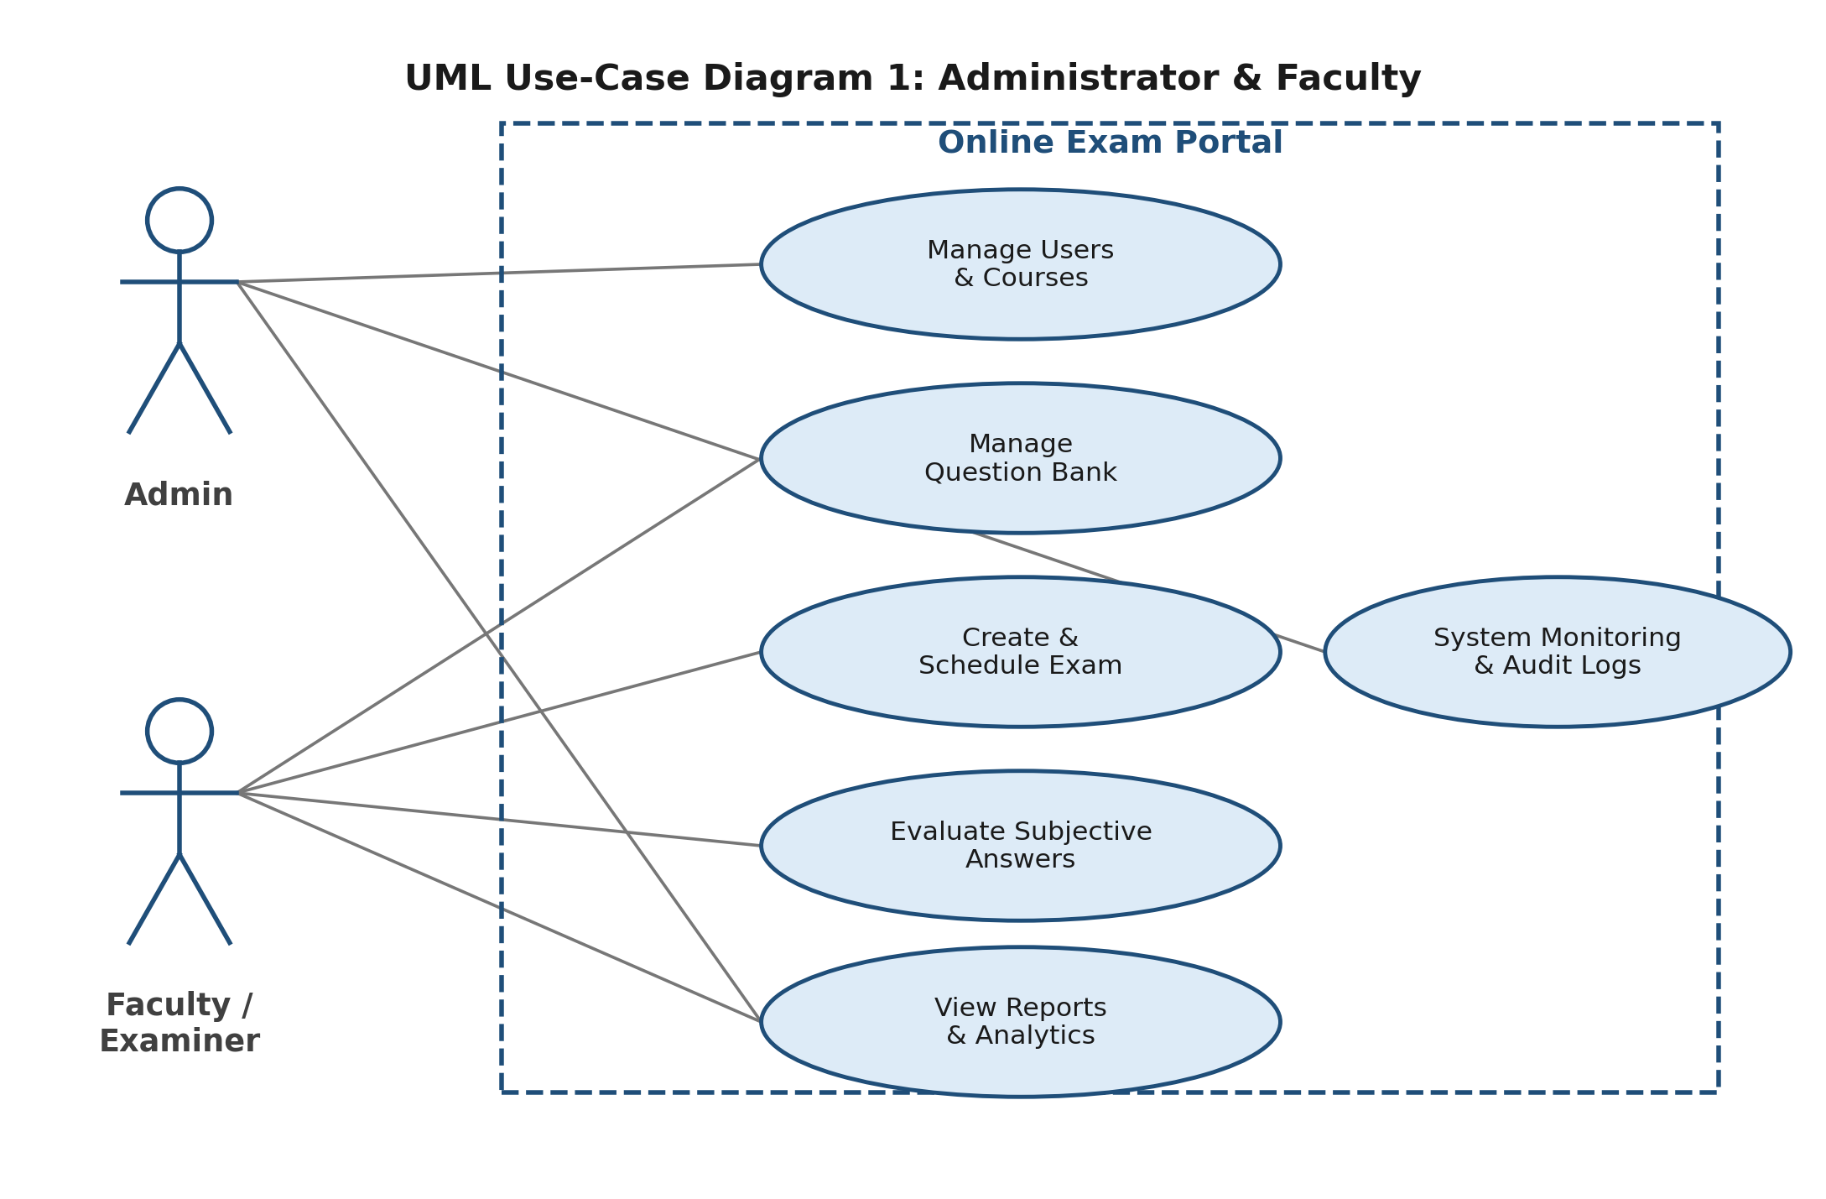
Figure 1: UML Use-Case Diagram — Administrator & Faculty
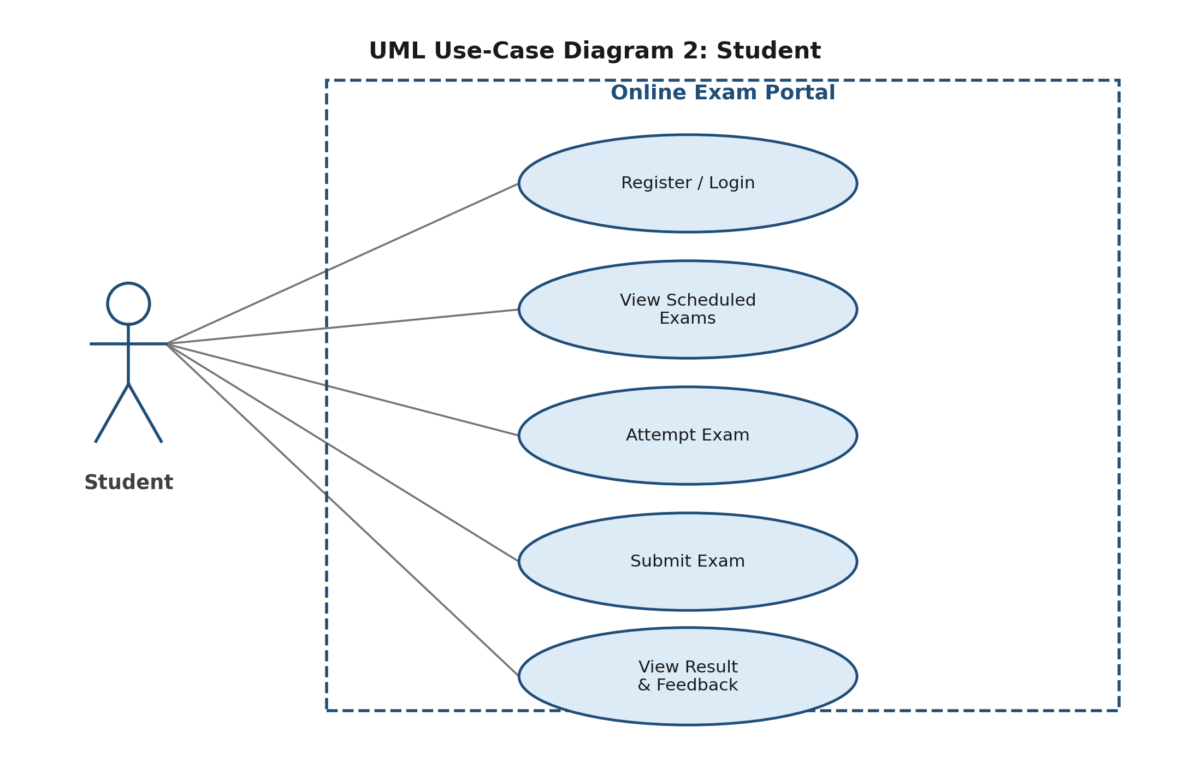
Figure 2: UML Use-Case Diagram — Student

8. Requirements Traceability Matrix (RTM)
Status: N = Not tested, P = Partially tested, A = All test cases passed. Updated as testing moves forward.
Req ID | Requirement (short) | Section | Module | Test case(s) | Status | Comments
OEP-F-001 | A new student can sign up using their institutional email … | 4.1 | AuthModule | TC-Auth-01 | N | -
OEP-F-002 | Users log in through a form that checks their email/userna… | 4.1 | AuthModule | TC-Auth-02 | N | -
OEP-F-003 | Role-based access is enforced for Admin, Faculty and Stude… | 4.1 | AuthModule | TC-Auth-03 | N | -
OEP-F-004 | After five failed login attempts in a row, the account is … | 4.1 | AuthModule | TC-Auth-04 | N | -
OEP-F-010 | Faculty can add MCQ, True/False and Short-Answer questions… | 4.2 | QuestionBankModule | TC-QB-01 | N | -
OEP-F-011 | Questions can be tagged by subject, topic and difficulty s… | 4.2 | QuestionBankModule | TC-QB-02 | N | -
OEP-F-012 | A whole batch of questions can be imported at once from a … | 4.2 | QuestionBankModule | TC-QB-03 | N | -
OEP-F-013 | Existing questions can be edited or removed, as long as th… | 4.2 | QuestionBankModule | TC-QB-04 | N | -
OEP-F-020 | An exam can be assembled either by hand-picking questions … | 4.3 | ExamSchedulingModule | TC-Exam-01 | N | -
OEP-F-021 | The exam creator sets the duration, total marks, per-quest… | 4.3 | ExamSchedulingModule | TC-Exam-02 | N | -
OEP-F-022 | An exam's availability window is defined with a start date… | 4.3 | ExamSchedulingModule | TC-Exam-03 | N | -
OEP-F-023 | Question order and the order of answer options are shuffle… | 4.3 | ExamSchedulingModule | TC-Exam-04 | N | -
OEP-F-024 | The exam can be assigned to specific student groups or cou… | 4.3 | ExamSchedulingModule | TC-Exam-05 | N | -
OEP-F-030 | While attempting the exam, students see the questions alon… | 4.4 | ExamDeliveryModule | TC-Deliver-01 | N | -
OEP-F-031 | Students can flag questions for review and move freely bet… | 4.4 | ExamDeliveryModule | TC-Deliver-02 | N | -
OEP-F-032 | Once the allotted time runs out, the exam is submitted aut… | 4.4 | ExamDeliveryModule | TC-Deliver-03 | N | -
OEP-F-033 | A student may submit the exam manually at any point before… | 4.4 | ExamDeliveryModule | TC-Deliver-04 | N | -
OEP-F-034 | A student cannot re-attempt the same exam instance a secon… | 4.4 | ExamDeliveryModule | TC-Deliver-05 | N | -
OEP-F-035 | Responses are auto-saved at regular intervals so a dropped… | 4.4 | ExamDeliveryModule | TC-Deliver-06 | N | -
OEP-F-040 | MCQ, True/False and fill-in-the-blank answers are graded a… | 4.5 | EvaluationModule | TC-Eval-01 | N | -
OEP-F-041 | Subjective / short-answer responses are routed to the rele… | 4.5 | EvaluationModule | TC-Eval-02 | N | -
OEP-F-042 | Faculty can award marks and leave written feedback on subj… | 4.5 | EvaluationModule | TC-Eval-03 | N | -
OEP-F-043 | Once both the objective and subjective components are grad… | 4.5 | EvaluationModule | TC-Eval-04 | N | -
OEP-F-050 | Each student gets an individual scorecard as soon as their… | 4.6 | ReportingModule | TC-Result-01 | N | -
OEP-F-051 | Faculty and Admin can pull up a class/course-level perform… | 4.6 | ReportingModule | TC-Result-02 | N | -
OEP-F-052 | Results and reports can be exported as PDF or Excel. | 4.6 | ReportingModule | TC-Result-03 | N | -
OEP-F-053 | Faculty can view a question-wise breakdown, e.g. the perce… | 4.6 | ReportingModule | TC-Result-04 | N | -
OEP-F-060 | Admin can create, edit and deactivate Faculty and Student … | 4.7 | AdminModule | TC-Admin-01 | N | -
OEP-F-061 | Admin manages courses/subjects and maps Faculty and Studen… | 4.7 | AdminModule | TC-Admin-02 | N | -
OEP-F-062 | Admin can review system-wide logs covering exam activity a… | 4.7 | AdminModule | TC-Admin-03 | N | -
OEP-F-063 | A diagnostic panel lets Admin check the health of the serv… | 4.7 | AdminModule | TC-Admin-04 | N | -
OEP-NF-001 | Everyday actions — logging in, moving between pages, loadi… | 5 | Cross-cutting / Performance | TC-Perf-01 | N | -
OEP-NF-002 | Submitted exam responses must never be lost, even if a stu… | 5 | Cross-cutting / Reliability | TC-Rel-01 | N | -
OEP-NF-003 | The exam server should stay up at least 99% of the time du… | 5 | Cross-cutting / Availability | TC-Ops-01 | N | -
OEP-NF-004 | Key actions — logins, submissions, evaluation changes, int… | 5 | Cross-cutting / Audit / Retention | TC-Audit-01 | N | -
OEP-NF-005 | The interface should be simple enough that a first-time st… | 5 | Cross-cutting / Usability / Accessibility | TC-UX-01 | N | -
OEP-NF-006 | The architecture should support scaling the application la… | 5 | Cross-cutting / Scalability / Maintainability | TC-Arch-01 | N | -
OEP-SR-001 | TLS 1.2 or higher is mandatory for every client-server con… | 5.1.2 | SecurityModule | TC-Sec-01 | N | -
OEP-SR-002 | Passwords are stored using a strong one-way hash (bcrypt o… | 5.1.2 | SecurityModule | TC-Sec-02 | N | -
OEP-SR-003 | Session tokens expire after a configurable idle period and… | 5.1.2 | SecurityModule | TC-Sec-03 | N | -
OEP-SR-004 | Exam questions and correct answers are never exposed in cl… | 5.1.2 | SecurityModule | TC-Sec-04 | N | -
OEP-SR-005 | An account is locked after five consecutive failed login a… | 5.1.2 | SecurityModule | TC-Sec-05 | N | -
OEP-SR-006 | Role-based access control is enforced at the server/API la… | 5.1.2 | SecurityModule | TC-Sec-06 | N | -

